# ARAVINTHAN S

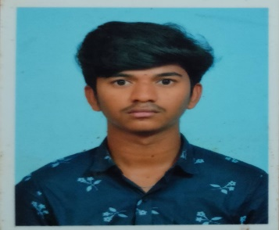

**Mobile No :** +91 6369811774

**Email :** aravinthan1570@gmail.com

**Address :** 83A,Pothakapatty,Ariyagoundampatty(PO), Namagiripettai,Rasipuram,Namakkal(DT)-637 406.

# CAREER OBJECTIVE

Seeking for an opportunity in an organization where I can exhibit my talent andenhance my skills to meet company goals and objectives with full integrity.

# ACADEMIC QUALIFICATION

|  |  |  |  |  |
| --- | --- | --- | --- | --- |
| **Course** | **Name of Institution** | **Board of Study** | **CGPA/**  **Percentage** | **Year of Passing** |
| **B.E [CSE]** | Muthayammal Enginnering College (Autonomous),  Rasipuram | Anna University | 8.0 | 2024  (Pursuing) |
| **HSC** | Kalaimagal Matric  Higher Secondary School,Namagiripet. | State Board | 60.5% | 2020 |
| **SSLC** | Kalaimagal Matric  Higher Secondary School,Namagiripet. | State Board | 74% | 2018 |

# PROFESSIONAL PROFICIENCY PROGRAMMING LANGUAGES KNOWN

* Java Programming

# SOFTWARE KNOWN

* + Intellij

# CERTIFIED COURSES

* Completed a “**Fundamentals of Artificial Intelligence**” course in NPTEL with 61%
* Certified on **“Problem Solving (Basic)”** by HackerRank.
* Certified on **“AWS For Beginners”** by Great Learning Academy.

# PAPER PRESENTATION

* Presented a paper on **“EDGE COMPUTING”** in Sengunthar Engineering College,Tiruchengode.

# INTERNSHIP

**Title :** Artificial Intelligence & Machine Learning

## Organization Name : AICL

**Duratrion :** 15 Days

# WORKSHOP

* Attended a workshop on **“Power Python”** conducted by LUDIFU.

# PERSONAL SKILLS

* Self Motivator
* Decision Maker
* Problem Solver
* Positive Thinker

# PERSONAL DOSSIER

**Father’s name :** Mr.K.Selvaraj **Mother’sname :** Mrs.S.Dhanalakshmi **Date of Birth :** 19-01-2003 **Blood Group :** O +ve

**Languages Known :** Tamil (Read-Write Speak),English (Read-Write-Speak),

**Nationality :** Indian

**LinkedIn :** **https://www.linkedin.com/in/aravinthan-s-93571924b**

# DECLARATION

I hereby declare that the above mentioned statements are true to the best of my knowledge.

**Date: SIGNATURE**

## Place: Rasipuram (ARAVINTHAN S)